ASSIGNMENT NO 12

1) Write a query that selects all customers whose ratings are equal to or greater than any of serres’.
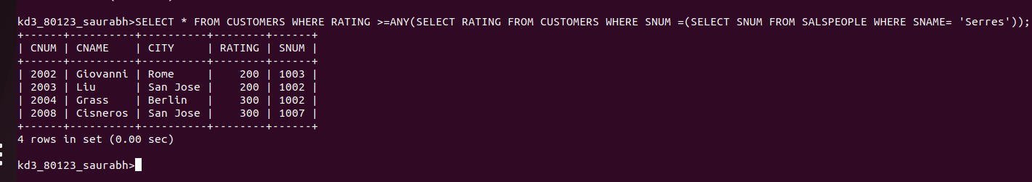

2) Write q query using ANY or ALL that will find all salespeople who have no customers located in their city.
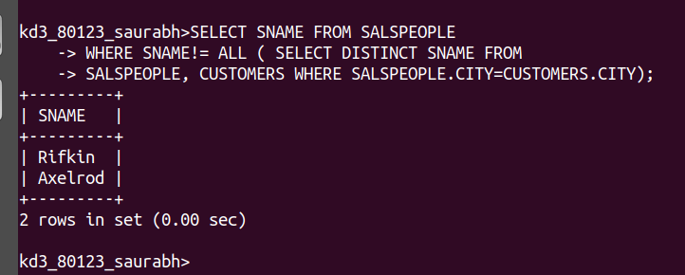

3) Write a query that selects all orders for amounts greater than any for the customers in LONDON

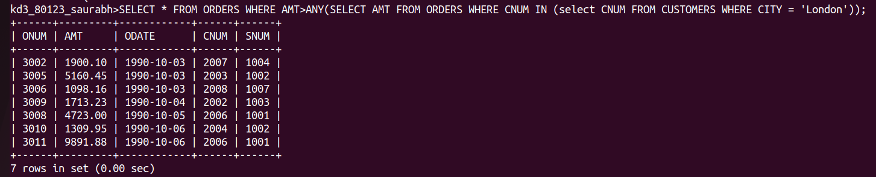
4) Write the above query using MIN or MAX.
